NOTICE OF PUBLIC HEARING

BEFORE THE
CITY OF PRYOR CREEK BOARD OF ADJUSTMENT

Notice is hereby given that on the April 15th, 2021, at 6:00 P.M. in the City Hall Council Chambers, located at 12 North Rowe Street, 2nd floor, Pryor Creek, Mayes County, Oklahoma, the City of Pryor Creek Board of Adjustment will consider a variance from the 50’ front setback and minimum lot 40% coverage.
LEGAL DESCRIPTION
Lot Numbered Five (5), in Block Numbered Fifty-Two (52), in the Incorporated Town of PRYOR CREEK, Mayes County, State of Oklahoma, according to the United States Government Survey and Plat thereof; AND Lot Numbered 6 in Block Numbered 52 in the Incorporated Town of Pryor Creek, Mayes County, State of Oklahoma, according to the United States Government Survey and Plat thereof. (121 S Taylor); AND A 10 foot strip of vacated Taylor Street lying West of and adjacent to Lot 6 in Block Numbered 52 in the Incorporated Town of Pryor Creek, Mayes County, State of Oklahoma, according to the United States Government Survey and Plat thereof, together will all and singular the hereditaments and appurtenances thereunto belonging.

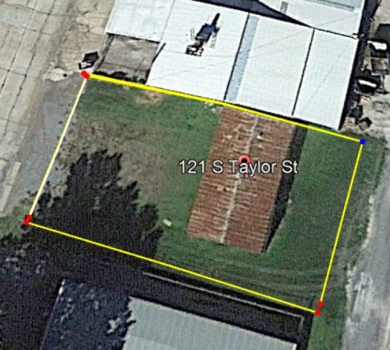

Anyone requiring special accommodations pursuant to the Americans with Disabilities Act should notify City of Pryor Creek at 918-825-0888.

